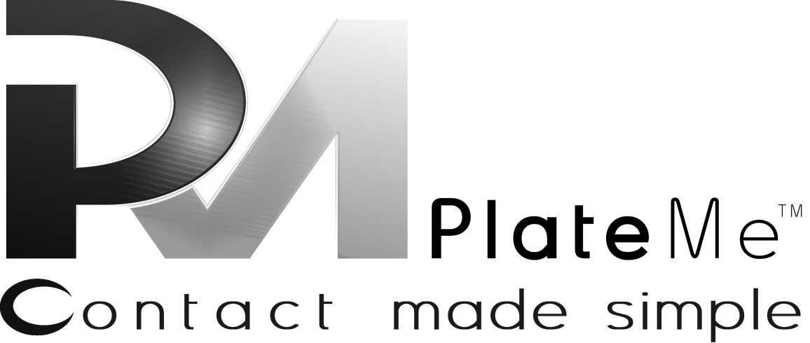
Web Division Agenda

This document is confidential and intended for its addressee(s) only, and may contain information which is privileged, confidential, and exempt from disclosure by law. For any reader who is not the intended recipient, any dissemination, distribution, or copying is prohibited, and request is herein made to notify the sender immediately by telephone and/or email reply. All information in this document belongs to the PlateMe Corporation. Misdirected delivery of this communication is not intended to waive privilege or to make public otherwise confidential information.

Weekly Team Status Report
Current Team:
Chief of Engineer – Shah El-Rahman

Open Positions:
- President of UI/UX Engineering
- President of Web Application Engineering
- Lead Data Aggregation Engineer
- Lead Quality Assurance Engineer
- Lead Security Engineer
- Lead User Experience Engineer
- Lead User Interface Engineer
- Lead Application Engineer
- Lead Database Engineer
- Engineer/Scientist with experience in Data Mining
- Engineer/Scientist with experience in Data Mining
- QA Engineer
- QA Engineer
- Software Engineer with experience in JavaScript
- Software Engineer with experience in JavaScript
- Software Engineer with experience in JavaScript
- Graphic Designer with experience in Web Applications
- Software Engineer with experience in Python/Java
- Software Engineer with experience in Python/Java
- Software Engineer with experience in Python/Java

This week:
- Restructuring code after team member losses
- Re-assessment of checklist
- Use Red Notification Indicator over Profile Image on the Header
- Show how many new notifications there are over each category
- Search by Name

Projects in process:
- Get Chat Working
- Get GPS Working
- Request/Share location
- Allow all post types in comments
- Advertising

Goals for next week:
- Continue working on items on checklists

